Lab 4: Vedanth Reddy Mapakshi : 20374094 : Computer Networks

1. Configuring static Ipv4 settings on my virtual machine on bridged mode. Configured as discussed in class.

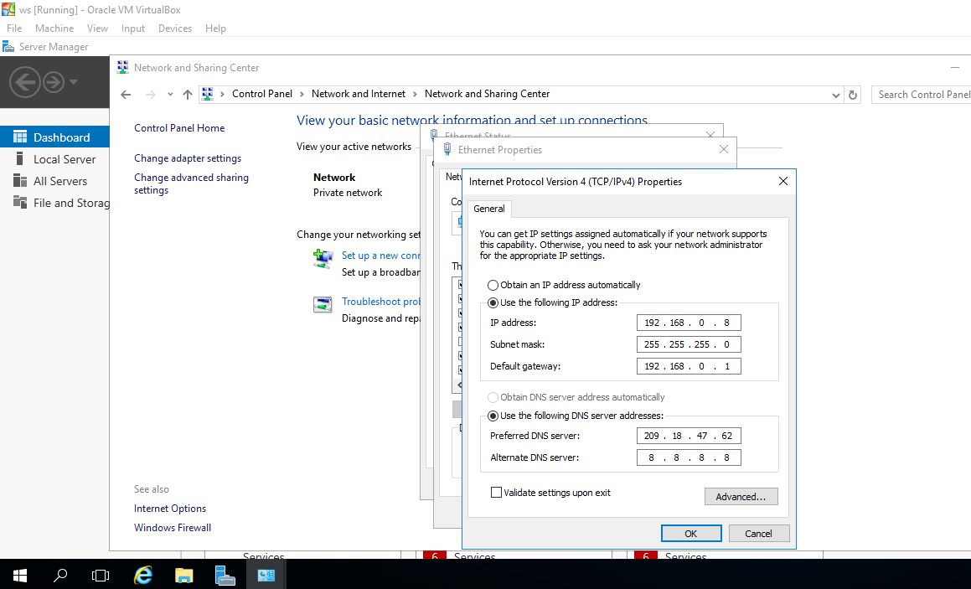

1. Installing active directory domain services from server manger

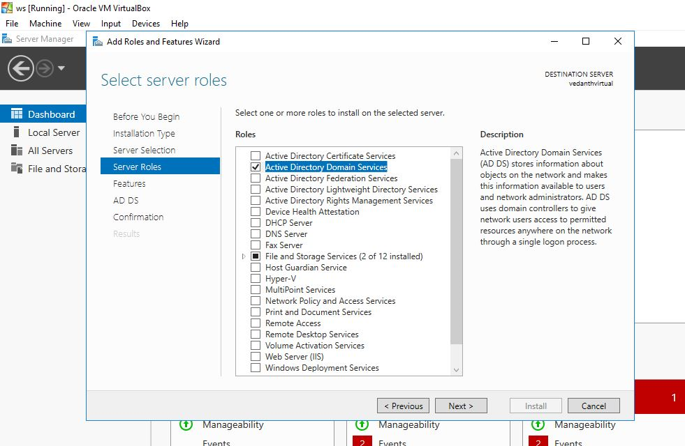

1. AD DS Configurations:

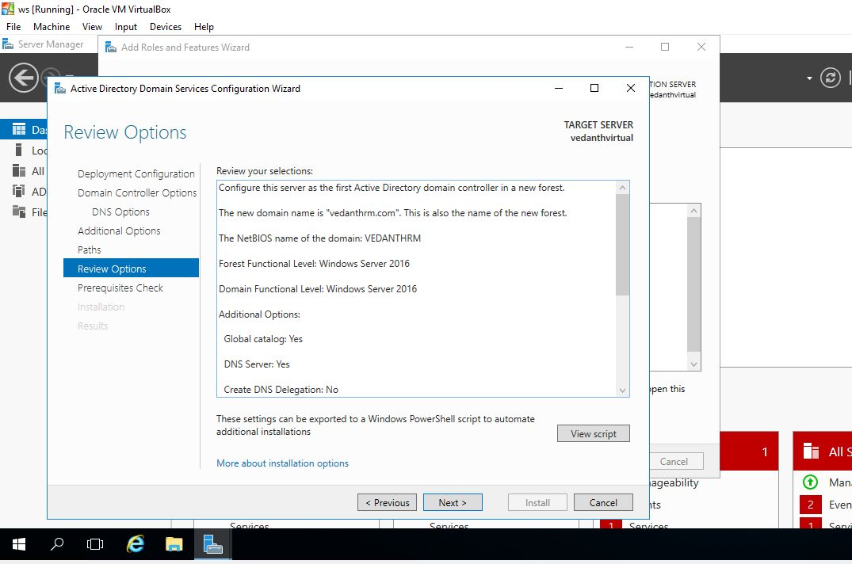

1. Domain controller setup:

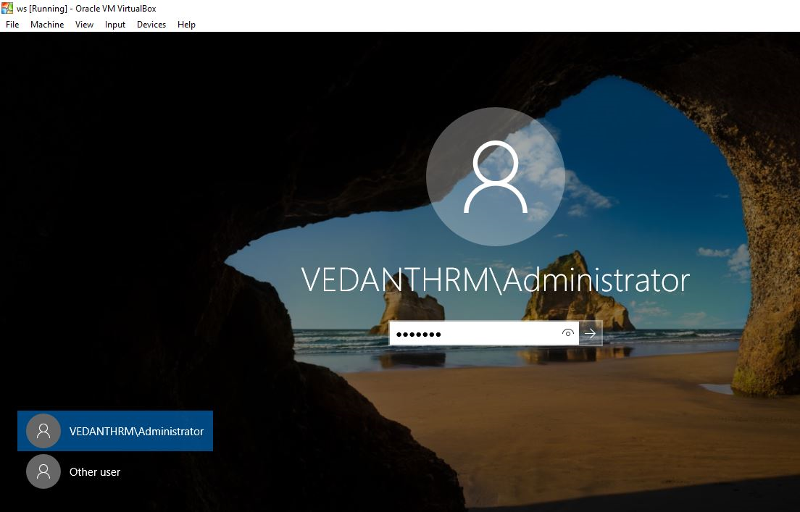

1. After that I configured DNS and added forward and reverse lookup zones
2. Configuration of DHCP and the Scope

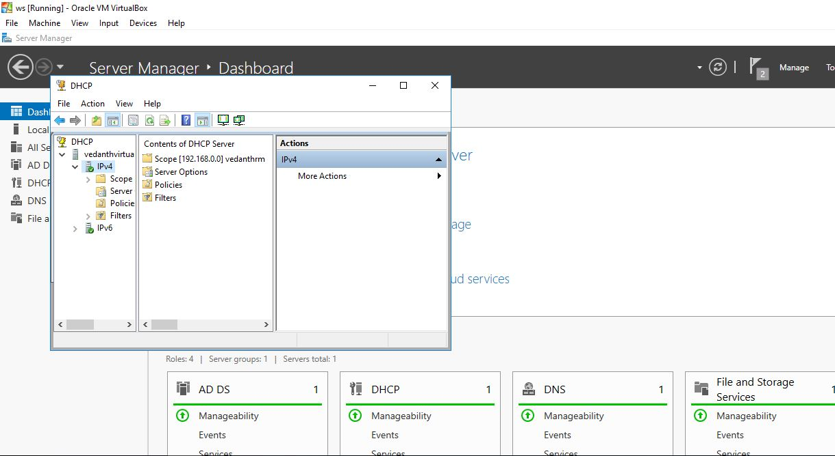

1. Installed Services

